To create an AWS account, follow these steps:
Step 1: Go to AWS Website
Visit:
AWS Official Website
Step 2: Click "Create an AWS Account"
- Click Create an AWS Account in the top-right corner.
- Enter:
  - Email address
  - Password
  - AWS account name
Step 3: Verify Your Email
- AWS sends a verification code to your email.
- Enter the code and continue.
Step 4: Add Contact Information
Choose:
- Personal account (for learning and practice)
- Business account (for organizations)
Fill in:
- Full name
- Phone number
- Address
Step 5: Add Payment Information
- Enter your debit/credit card details.
- AWS requires a valid card for identity verification.
- You may be charged a small temporary verification amount.
Step 6: Phone Verification
- Enter your phone number.
- Receive an OTP via SMS or voice call.
- Enter the OTP to verify.
Step 7: Select a Support Plan
Choose:
- Basic Support (Free) ✅ Recommended for beginners
- Developer Support
- Business Support
- Enterprise Support
Step 8: Sign In to AWS Console
After account creation, log in through:
AWS Management Console
Step 9: Secure Your Account
Immediately:
- Enable Multi-Factor Authentication (MFA) on the root account.
- Create an IAM User instead of using the root account daily.
- Set up billing alerts using AWS Billing and Cost Management.
What is EC2?
EC2 (Elastic Compute Cloud) is a cloud service provided by Amazon Web Services (AWS) that allows you to create and run virtual servers in the cloud.
Think of an EC2 instance as a computer running in AWS data centers that you can use to:
- Host websites
- Run applications
- Deploy databases
- Practice Linux and DevOps tools
- Run CI/CD pipelines
How EC2 Works
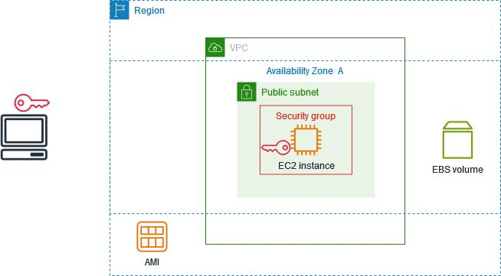
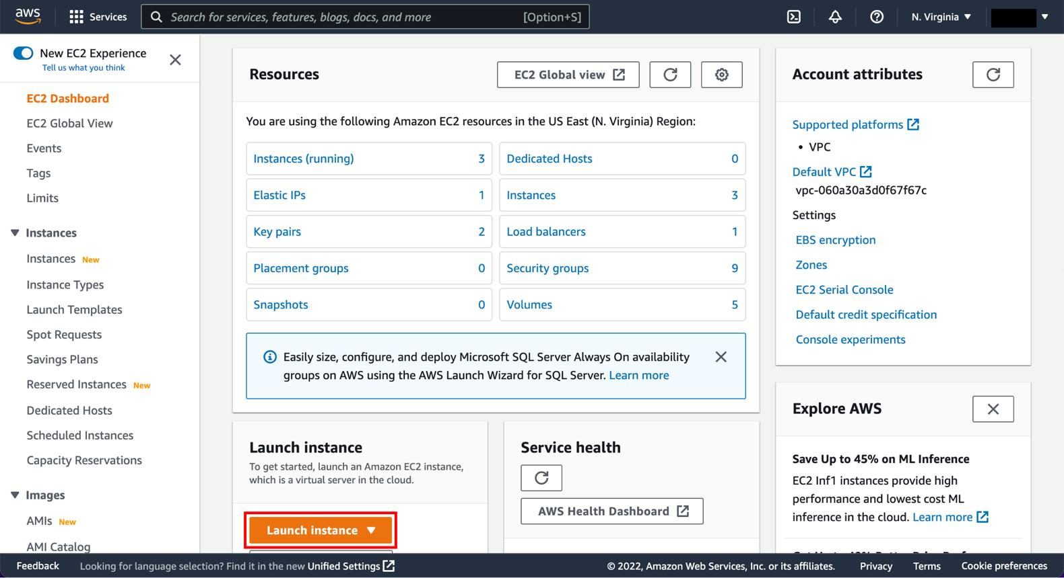
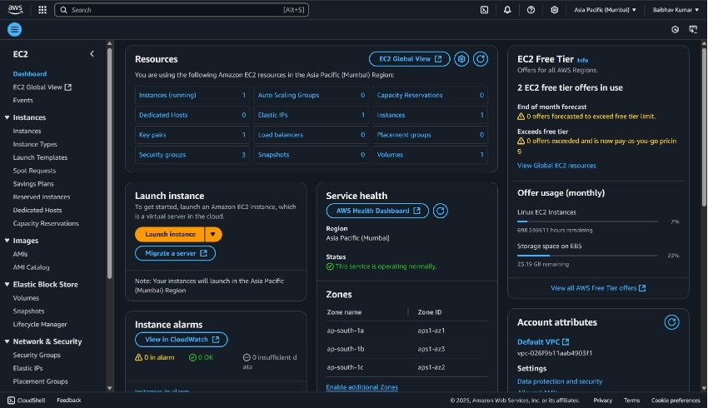
4
- Create an EC2 instance.
- Choose an operating system (Ubuntu, Amazon Linux, Windows, etc.).
- Select the CPU and RAM size.
- Launch the instance.
- Connect to it using SSH (Linux) or RDP (Windows).
- Install and run your applications.
Key Features
- Scalable – Increase or decrease resources as needed.
- Pay-as-you-go – Pay only for what you use.
- Secure – Control access using security groups and IAM.
- Flexible – Supports multiple operating systems.
Example
Suppose you want to host a website:
- Launch an Ubuntu EC2 instance.
- Connect via SSH.
- Install Nginx:
sudo apt update
sudo apt install nginx -y
- Open port 80 in the Security Group.
- Access your website using the EC2 public IP.
Important EC2 Components
- Instance – The virtual machine.
- AMI (Amazon Machine Image) – Template used to create instances.
- Security Group – Virtual firewall.
- Key Pair – Used for secure login.
- EBS (Elastic Block Store) – Storage attached to EC2.
Common EC2 Instance Types
- t2.micro / t3.micro – Free Tier eligible, good for beginners.
- t3.small – Small applications.
- m5.large – General-purpose workloads.
- c5.large – Compute-intensive workloads.

